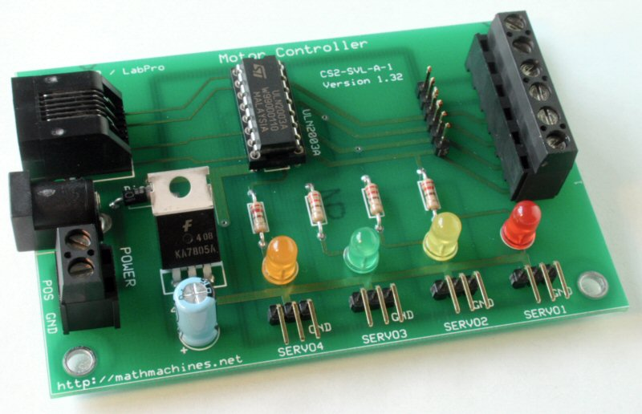
Motor Controller
This Motor Controller can operate either one unipolar stepper motor or four servo motors. It was originally designed for use with TI graphing calculators and a CBL2 or LabPro interface. With appropriate connectors, it can be controlled by any interface which provides four 5-volt data lines and reference ground. It requires an external DC power supply, connected either through screw terminals or a 2.1 mm, center positive jack.
Important information regarding the motors:
- Unipolar stepper motors are available to operate at a wide range of voltages. This controller can operate between 6 volts and 24 volts, but the current per coil should not be greater than 0.35 A. (Stepper motors typically use 2 coils at once, so the total current they draw is twice the current per coil.) It is essential that you match the current and voltage specifications of any stepper motor you plan to use with the capabilities of the power supply and the Motor Controller.
- You can recognize unipolar stepper motors by the fact they have either 5 or 6 wires. Bipolar stepper motors with only 4 wires or motors with more than 6 wires will not work with this controller.
- Most popular hobby servo motors will work with this controller. These require 5 volts, but the input voltage to the Motor Controller must be at least 6 V for the electronics to function correctly. When used with servo motors, the ideal input voltage to the board is 6 V.
- The CBL2 or LabPro can be used to position any one of up to 4 servo motors, but these interfaces can send continuous signals to only 1 servo motor at a time. Generally, “digital” servos will hold their position after the signal has stopped, but “analog” servos will lose power when their signal stops and may fall away from the set position. The bottom line is that “digital” servos are preferred if you want to use more than one servo.
- Unfortunately, neither the CBL2 nor the LabPro is able to produce the high-precision pulses needed for precise positioning of high-quality servo motors. The original CBL was much better in this regard. Contact STEMmachines@gmail.com if you would like information about using the original CBL.
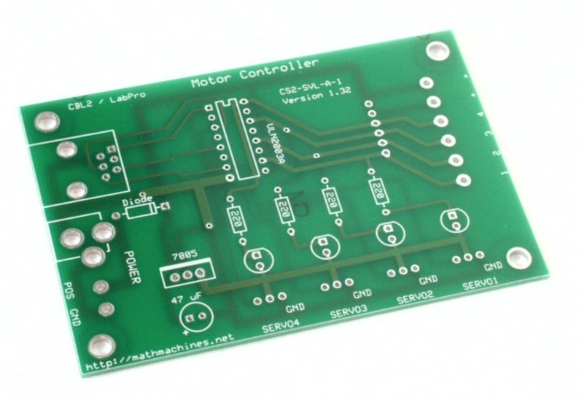
Step 1 -- Orientation to Printed Circuit Board
Look at the printed circuit board (PCB) and be sure you understand how it should be oriented. All of the components (except for 4 rubber feet) will be placed on top of the board while it is oriented as shown at right. You will then turn the board over and solder from the bottom.
Notice that the board is "double sided," meaning that it has lines of metal printed on both top and bottom. These metal traces are the "wires" which will conduct electricity. Look closely at some of the holes on the board. They are "plated through" so that metal goes through the board at those points. The board is also coated with a protective covering, so that metal is only exposed in and around the holes. Some of the largest holes have no metal traces, since they will be used for mechanical connections, not electrical connections.

Step 2 -- Identify the Components
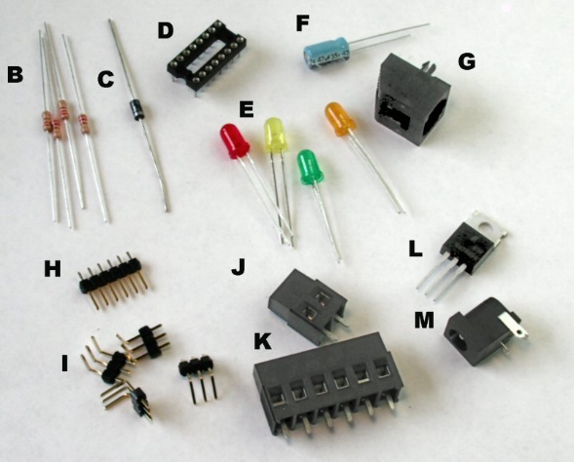
The parts to be attached to the PCB are shown at right. Identify each, and lay them out where you can keep track of them. The letters indicate the recommended order of assembly.
A | Printed Circuit Board | 1
B | Resistors, 220 ohm (red, red, brown) | 4
C | Diode, 1N4001 | 1
D | Socket, 16 pin, DIP | 1
E | LEDs (red, yellow, green, orange) | 4
F | Capacitor, 47 micro F, radial leads | 1
G | Phone jack, 6P6C | 1
H | Straight header, 6 position | 1
I | Right-angle headers, 3 position | 4
J | Terminal block, 2 position | 1
K | Terminal block, 6 position | 1
L | Voltage regulator, 7805 | 1
M | Power jack, 2.1 mm | 1
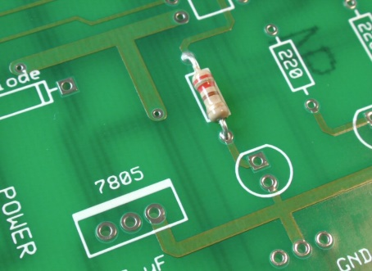
Step 3 -- Add the First Resistors
- Be sure that you and all the people near you are wearing eye protection.
- Be very alert to the fact that the soldering iron is hot.
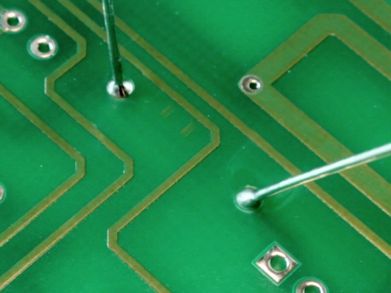
Insert one of the 220-ohm resistors from the top of the PCB. The resistor conducts current equally well in either direction, but good practice requires that you orient the resistor so its color code can be read from the top down. The resistor has colored bands of red, red and brown (for 22 x 10¹) and a gold band to indicate 5% tolerance. Red should be at the top.
Turn the board over and solder the 2 leads. When finished, you should see a small "candy kiss"-shaped mound of solder that clings to both the solder pad on the PCB and to each of the resistor's wire leads. You should also be able to see that the solder has passed through the hole in the PC board.
Before continuing, use the side cutters to cut off the excess wire, being very careful to protect your eyes and the eyes of everyone around you.
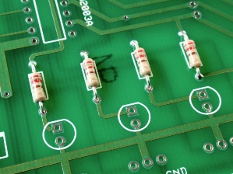
Step 4 -- Add the Other Resistors
Solder the other 3 resistors into place in the same way as the first one.
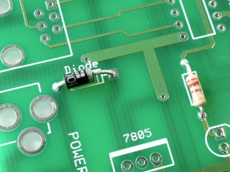
Step 5 -- Put in the Diode
Solder the diode into place as shown. Unlike the resistors, the diode must be oriented at shown, since it only conducts electricity in one direction. If fact, its function on the board is to ensure that electricity will not flow backwards through the circuit even if someone connected the power supply backwards.
After you solder both leads, again use the side cutters to trim the excess wire.

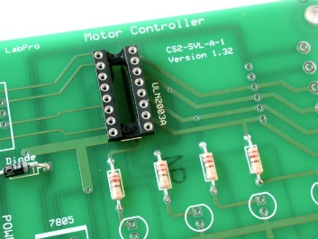
Step 6 -- Add the Socket
The socket will hold the ULN2003A integrated circuit (IC) which is the work horse of this motor controller. The IC could be soldered directly to the board, but using a socket protects the IC from possible damage during soldering and it also makes it much easier to replace the IC if that is ever necessary.
Note that the socket has a notch at one end. It is important to orient this notch towards the top of the board, matching the outline on the PC board. Electrically, the socket will work fine either direction, but the notch is an important reminder of how the integrated circuit (IC) chip must be oriented. It is especially important to have the socket oriented correctly in case you or someone else ever needs to replace the IC.
Solder all of the pins in place. It is not necessary to cut off the pins
Hint -- It may be helpful to use a piece of masking tape to hold the socket to the board until you have soldered at least a few pins.
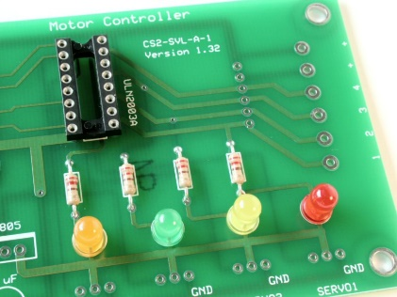
Step 7 – Put in the LEDs
The light-emitting diodes (LEDs) have electrical properties very similar to the other diode, but they are used for a totally different purpose--to give off light. Each one will signal when one of the circuit's four lines is active.
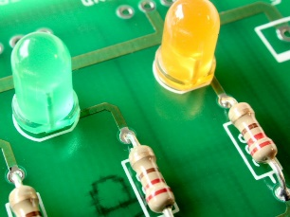
Notice that each LED must be oriented correctly, with its negative terminal closest to the resistor. You can identify the negative terminal of the LED by the fact that its lead is shorter and by the presence of either a notch or a flat side on the plastic. On the PC board, the negative side of an LED is "pin 1" and is identified with a square pad rather than the usual round pad. When you have them oriented correctly, solder each diode into place.
Step 8 – Add the Capacitor
This is an electrolytic capacitor, and its orientation is very important. If you get it backwards, it is possible that the capacitor will (literally) blow its top.
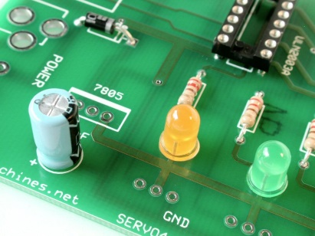
Notice that capacitors are numbered with "pin 1" as the positive terminal and the one with a square pad. Be sure you know which is the negative side of the capacitor (marked on the plastic cover) and that you insert it correctly into the board.
Solder and trim the two leads.
A square pad always indicates “pin 1” and is not a consistent indicator of positive or negative or any other specific function.
The capacitor's job is to help stabilize the voltage in the circuit, especially when stepper motor coils are turned rapidly on and off. It acts a bit like a flood-control dam, storing current when there's too much and releasing current when there isn't enough.
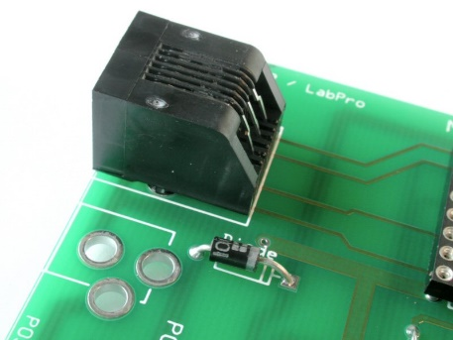
Step 9 – Modular Jack
The modular jack provides a place to connect the Motor Controller board to the CBL2 or LabPro. It is like a US-style telephone jack, but has 6 connectors rather than 4.
Carefully align the 6 pins then snap the 2 plastic supports into place. Solder all 6 pins.
Note that these pins are smaller and closer together than most others on the board. They will not require as much heat or as much solder.

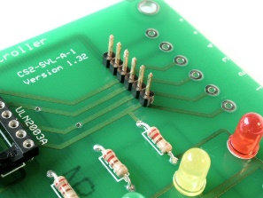
Step 10 – More Connectors
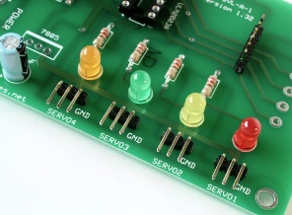
"Headers" provide a low-cost, convenient way to make electrical connections. Some stepper motors come with connectors that fit on 5- or 6-pin headers, and almost all hobby servo motors come with connects for 3-pin headers. The headers on the motor controller will allow you to use it with either a single stepper motor or up to 4 servo motors. If you try to connect both types of motors simultaneously, at least one will behave erratically.
Use masking tape to hold the headers (1 6-pin and 4 3-pin) in place as shown, then solder them. Be sure the plastic is firmly against the PC board, but don't press too hard or the pins might slip through the plastic.
Note: The headers often come in longer strips, and you may need to break them apart.
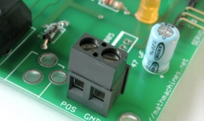
Step 11 – Still More Connectors
Screw terminals provide a secure, semi-permanent way of making connections. The 2-position terminal block provides one option for connecting the Motor Controller to a power supply. The 6-position terminal block is an alternative to the straight header when connecting stepper motors.
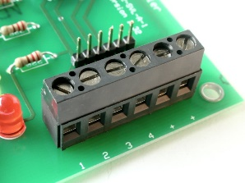
Be careful to orient the terminal blocks with their openings toward the outside edge of the board. Also note that the pins and holes are relatively large, so the solder connections will require more heat and more solder than some of the other connections.
Solder both connectors into place. It is not necessary to trim off the pins.
Step 12 – Voltage Regulator
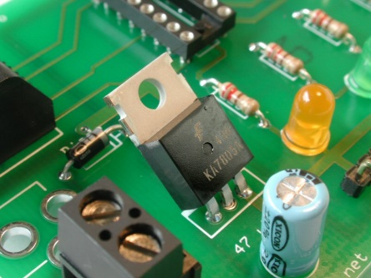
Stepper motors work with a wide variety of voltages, and this Motor Controller can accommodate voltages from 6 V to 24 V (so long as the current per phase does not exceed 0.35 amps). To drive the motors, you will need to use a DC power source that matches the voltage requirement of your stepper motor.
Servo motors and LEDs, on the other hand, generally use lower voltages. The "7805" is a voltage regulator that accepts voltages up to 24 V and provides a constant output at 5 V. To give you the required 5-volt output, the input needs to be at least 6 volts.
Insert the voltage regulator as shown, with the printed surface facing forward, and solder all 3 leads. Trim the leads and bend the voltage regulator backwards a bit so it doesn't stick up above the other components.
In normal operation--especially when running several servo motors--the voltage regulator's heat sink (the metal part with the hole) may be quite warm. Make sure it is not touching any other components.

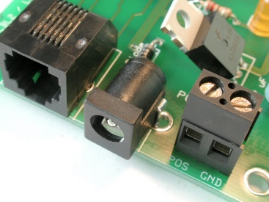
Step 13 – Power Plug
You can use the 2-position terminal block to provide energy to the Motor Controller, but sometimes it is easier to use a plug-in DC power source. This plug includes a built-in switch which disconnects the terminal block when you insert a plug. It is helpful to use masking tape to hold the power plug in place while you work. Also use pliers to bend the terminal inward so they make good contact with the inside of the holes in the board, then solder each terminal into place.
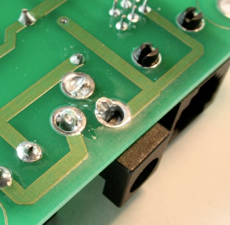
The power plug is wired to accept a 2.1 mm plug that is center positive. The power source you use must match the voltage and current requirements of the motors you use, but it should never exceed 24 V. The maximum current capacity is 0.35 A per phase, and stepper motors normally use two phases simultaneously. The current capabilities of your power source should match the total current requires for the motor or motors you will use.
Note: If you decide not to use the power plug, you will need to add a jumper wire between the two front terminals holes.
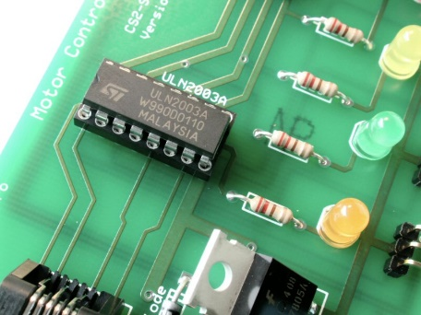
Step 14 – Final Assembly
The soldering is finished, but there are still some important steps.
Carefully align the ULN2003A integrated circuit (IC) with its socket. Recall that the notch in the chip must match the notch in the socket. (Some ICs have a dot, instead of a notch.) The pins on the IC flare outwards (because they are most often inserted by robots), and you may need to bend them slightly to make sure that each pin is resting directly in a hole of the socket. When you are sure the pins are all aligned, push downward firmly on the IC to seat it securely. Look carefully to make sure all 16 pins actually went into the correct holes. If one bent off in another direction, you must remove the IC, restraighten the pins and try again.
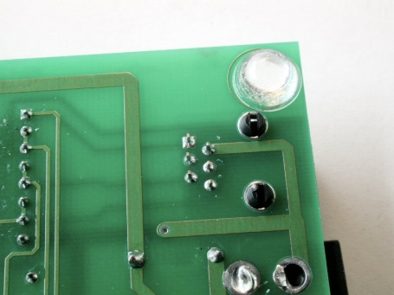
The ULN2003A is a "Darlington array," used as a 7-channel switch. A small signal to a pin on the lower side of the IC connects the opposite pin to ground. The IC also includes built-in diodes to help control the voltages induced as motor coils switch on and off. Since we only need 4 channels for our application, the extra three are wired in for redundancy.
Since the bottom of the board includes exposed electrical conductors, it is important to keep the board from touching anything below it. Stick an insulated foot onto each corner of the board. (If your Motor Controller board will eventually be mounted on a robot, you may want to use screws and standoffs, rather than the stick-on feet.)
Step 15 -- Prepare the Cable
This can be complicated, or you can contact Math Machines for a simple solution.
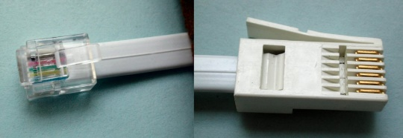
The CBL2 and LabPro use British Telecom (BT) plugs. Analog input probes (for CH 1, etc.) use BTA plugs with a right-hand release. BTA plugs are great for getting data into the interface, but they won’t work this switch. The Digital ports, require BTD plugs with a left-hand release. To connect this switch to your CBL2 or LabPro, you need a cable with a BTD plug on one end and a correctly oriented US 6-position, 6-connector (RJ12, 6P6C) plug on the other end.
You can buy a BTD plug and cable from Vernier as part number CB-BTD, which has bare wire at its other end. You can also buy a Digital Sensor Cable (MDC-BTD) and cut it in half to get two BDTs with bare wire ends. As of January 2022, either option costs $5 plus shipping. Also note that the cables are round, not flat, which can make the process of connecting an RJ12 plug more difficult.
Math Machines have a number of ready-to-use cables with the needed BTD on one end and RJ12 on the other end. Current cost is $4 each, including postage within the US.
Contact us at 10082 Dove Drive, Freeland, MI 48623 or email STEMmachines@gmail.com for more information.
Step 16 – Testing and Exploring
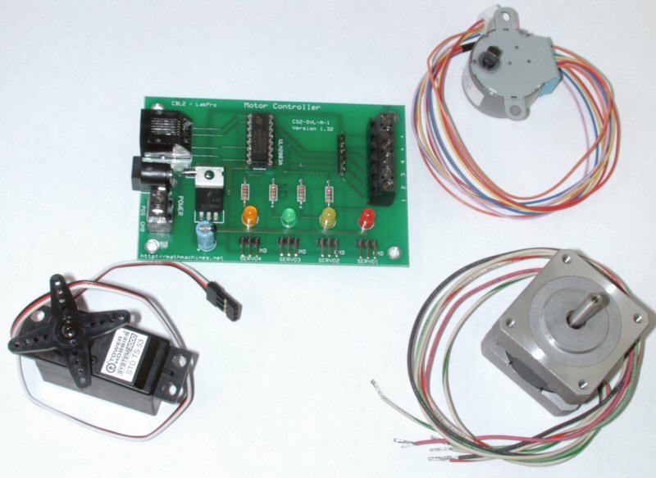
- Connect the board to a 12-V power source. Touch the IC and the voltage regulator to make sure they are not getting hot. If either is distinctly warm, disconnect the power source immediately and start looking for the short circuit.
- Connect the board’s modular jack to the CBL2 or LabPro using the appropriate cable. Also connect a calculator to the CBL2 or LabPro using the “link” cable. Run the SIGNAL program and verify that all 4 LEDs turn on and off under control of the program.
- Attach a servo motor to the various servo headers, with the black ground wire to the right. Turn the power back on to the board and use the SERVO program to verify that the servos respond. Before running each program, you must store an angle in degrees (between -90 and +90) as the variable “A” (for example, 45 [STO>] A) and then run the program. After the motor moves to position A, it should remain in or close to the same position, until you change the value for “A” and run the program again. Disconnect the servos before continuing. The Motor Controller is designed to run either servo motors or a stepper motor. It cannot operate both at once.
- Attach the 5 or 6 wires of a stepper motor to one of the 6-position terminals. Your group leader will help you connect the available motors. Run the STEPPER program and verify that you can make the stepper motor turn in either direction at a variety of speeds.
- If time and equipment are available, experiment with other devices. The Motor Controller can control up to 4 different 12-V DC devices, such as buzzers, lights, etc. To operate a 12-V buzzer, for example, connect the buzzer’s positive input to one of the “+” terminals and connect its negative input to terminal 1, 2, 3 or 4. You should make sure that no one device has a resistance less than about 40 ohms, so the current in each channel stays below .3 A. The TOTAL current for all 4 channels should not exceed .6 A. You can use the SIGNAL program to operate the device.
- You might also want to try a linear stepper motor if one is available.

 | Motor Controller
Order | Component | # per board | Supplier | Part Number
A | Circuit Board | 1 | Math Machines | CS2-SVL-A-1
B | Resistors, 220 ohm, 1/4 W | 4 | Mouser | 291-220
C | Diode, 1N4001 | 1 | Jameco | 35975
D | Socket, DIP 16 pin MIL Max | 1 | Mouser | 575-199316
E1 | LED (red) | 1 | Jameco | 94511
E2 | LED (yellow) | 1 | Jameco | 34825
E3 | LED (green) | 1 | Jameco | 34761
E4 | LED (orange) | 1 | Jameco | 107393
F | Capacitor, Electro, Radial, 47 microF | 1 | Mouser | 140-XRL35V47
G | Phone jack, 6P6C, PCB mount, side entry | 1 | Mouser | 571-5551651
H | Straight header, .1", 6P | 1 | Mouser | 517-6111TN
I | Right Angle header, .1", 3P | 4 | Jameco | 103270
J | Terminal Block, 2-position | 1 | Mouser | 571-7969492
K | Terminal Block, 6-position | 1 | Mouser | 571-7969496
L | IC, 7805 Voltage Regulator | 1 | Jameco | 51262
M | Power Jack, 2.1 mm | 1 | Mouser | 163-5004
N | Darlington Array, ULN2003A | 1 | Mouser | 511-ULN2003A
 | EITHER
O | Rubber feet | 4 | Mouser | 517-SJ-5306CL
 | OR
P | 6-32 x 3/8" spacer (nylon) | 4 | Mouser | 561-L6.375
Q | 6-32 x 1/4 Machine Screw (nylon) | 4 | Mouser | 561-P632.25
 | Cable
 | LabPro Dig Sonic to Modular Jack | 1 | Math Machines
 | Suggested Power Source
 | 13.5 V, 15 W AC Adapter |  | Mouser | 418-TR1512-01
 | Suggested Servo Motors
 | Futaba S3003 |  | Tower Hobbies | LB7038
 | TS-53 Standard Servo |  | Tower Hobbies | LXUK84
 | Suggested Stepper Motors
 | 15 deg step, geared 1:85.25 (low cost) |  | Jameco | 237761CL
 | 7.5 deg step, ungeared |  | Jameco | 35BY48B09
 | 1.8 deg step, ungeared (high quality) |  | Applied Motion | 5017-008

For additional information about these parts or to inquire about kits or workshops, please email: STEMmachines@gmail.com
Revised 12-January-2022

